**Directions:** Using the four prompts below, identify how the FoodieLand app demonstrates good UX design.

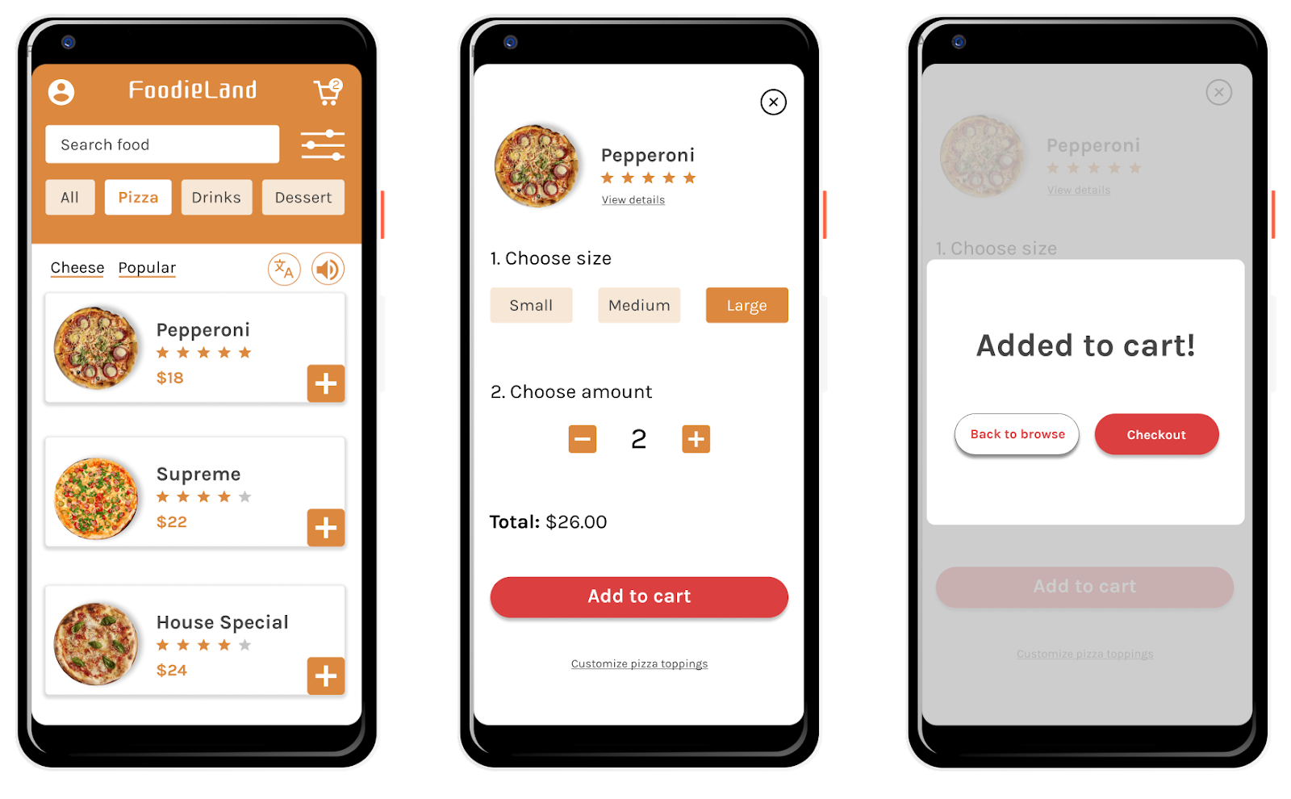

Prompt 1: Identify at least one aspect of the FoodieLand app that demonstrates usable design. Explain your reasoning in 1-2 sentences.

|  |
| --- |
| Hint: Is the app’s design, structure, and purpose clear? Does the app have any elements or features that make it easy to navigate? |

|  |  |
| --- | --- |
| **Usable** | The design of the app is clear and the purpose is clear that it is used for online food ordering and menu can be searched using the search bar. Anyone who opens the app can easily select items and add them to the cart and the colors clearly differentiate each of the icons. |

## 

## Prompt 2: Identify at least one aspect of the FoodieLand app that demonstrates equitable design. Explain your reasoning in 1-2 sentences.

|  |
| --- |
| Hint: Does the app address the needs of people with diverse abilities and backgrounds? |

|  |  |
| --- | --- |
| **Equitable** | The design of the app is equitable in the aspect that, it supports multiple languages and has audio assistance to help those with disabilities. The app equally has multiple sizes for dishes as small, medium and large. |

## Prompt 3: Identify at least one aspect of the FoodieLand app that demonstrates enjoyable design. Explain your reasoning in 1-2 sentences.

|  |
| --- |
| Hint: Does the app inspire a positive reaction from the user by considering their thoughts and feelings? Does the app engage users and make them excited to keep using the app? |

|  |  |
| --- | --- |
| **Enjoyable** | The app is not only functional and efficient but it also displays attractive menu pictures of different foods. The app looks colorful and easily navigable to order food which attracts users to return to the app for ordering of food. |

## 

## Prompt 4: Identify at least one aspect of the FoodieLand app that demonstrates useful design. Explain your reasoning in 1-2 sentences.

|  |
| --- |
| Hint: Does the app solve the problem of “how to help a busy person working from home select a meal to be delivered?” How does the app help solve this problem? |

|  |  |
| --- | --- |
| **Useful** | The app is useful since someone can order from home while choosing different sizes and quantities as desired. Different foods can be ordered at once when they are selected and added into the cart. |